Title TBD Roguelike Game Concept and Progression

Juda Montufar
Main Programmer, Artist

Angelique Rodriguez
Main Storywriter, Programmer, Visual Artist
Martin Reyes
Programmer

Thien Le
Visual Artist

Chris Hernandez
Mechanics Designer, Visual Artist

Josue Ochoa
Main Storywriter, Main Music Composer, SFX Artist

Basic storyline:
The main character goes out of town to run errands for their family. Upon returning the entire town is burnt to the ground with an “angel” standing on the ruins. The main character stands in shock until they are spotted by the “angel” who then proceeds to chase them down. The character runs away in fear but then falls into a pit. Thinking that the main character is dead the “angel” leaves, not realizing that the person is alive. They crawl their way out of the pit only to find two angels flying above the remains of the town. The angels approach the character, explain that it was really a demon that killed the entire village in order to collect essence, and assign the role of slaying the demon to the main character. The main character goes on a journey, following the trail of destruction, upgrading weapons, gaining abilities, and attacking mobs all for the purpose of getting revenge on the demon.

Gameplay and Fighting Mechanisms:

Gameplay
- Level Grading
- For certain events in each level, a calculation will be performed that determines the player’s overall success in that level called their “Grade.” Defeating mobs, destroying certain terrain, and beating the level all contributes to their grades. In the event that the player is unable to beat the level, they fail the level and receive an F, at which point they are able to restart.

- Game Progression
- The player, after beating each level, or “Biome,” will be allowed to progress onto the next zone.

- Mini-bosses
- These enemies have increased stats such as HP and attack stats. Upon defeat, they have the ability to drop the weapon that they used during the fight.

- Currency
- Each enemy will drop “essence” which will serve as the game’s currency. Essence will drop at different rates depending on the type of enemy killed. The currency will be able to be used in shops to upgrade or obtain new gear.

- Shops
- Obtain potions, upgrade base stats, etc. using essence.

Fighting Mechanisms

- Parrying
- You get a small window where you become invincible and return the damage back to its recipient.

- Dash
- A sudden movement forward which can be used to evade attacks or close distance between enemies and player after pressing a button (TBD). At a certain point in this game, the player will have the ability to upgrade this dash after which the dash will provide a moment of invincibility, allowing the player to avoid enemy damage.

- Melee Slash
- Choose between various weapons, such as daggers, swords, and axes.
- Bow and arrow projectile(different directions)
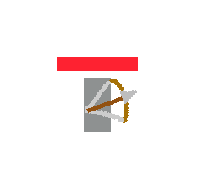
- Potions
- Various buffs, like speed, strength, magic, etc.
- Spells
- tbd

Placeholder Designs:
Maps - Thien Le:
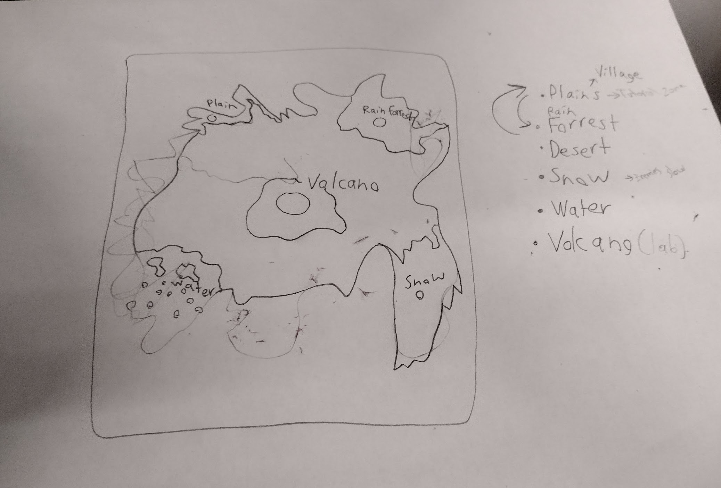
Currency(Essence) - Thien Le:

Main Character - Thien Le: 

Demon (Faker Form) - Chris H:
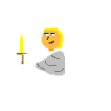

Map design: TBD
The goal is to have a platformer rogue-like game that leads the character through different terrains with different mobs in each town. The reason why the character is traveling from town to town is because they are following the trail of destruction left by the demon and his mob army.

Current progress for the Water Town:
I have yet to add:
- Town in ruins
- More water details
- Clouds
Water Background Design - Angelique (Scrapped)
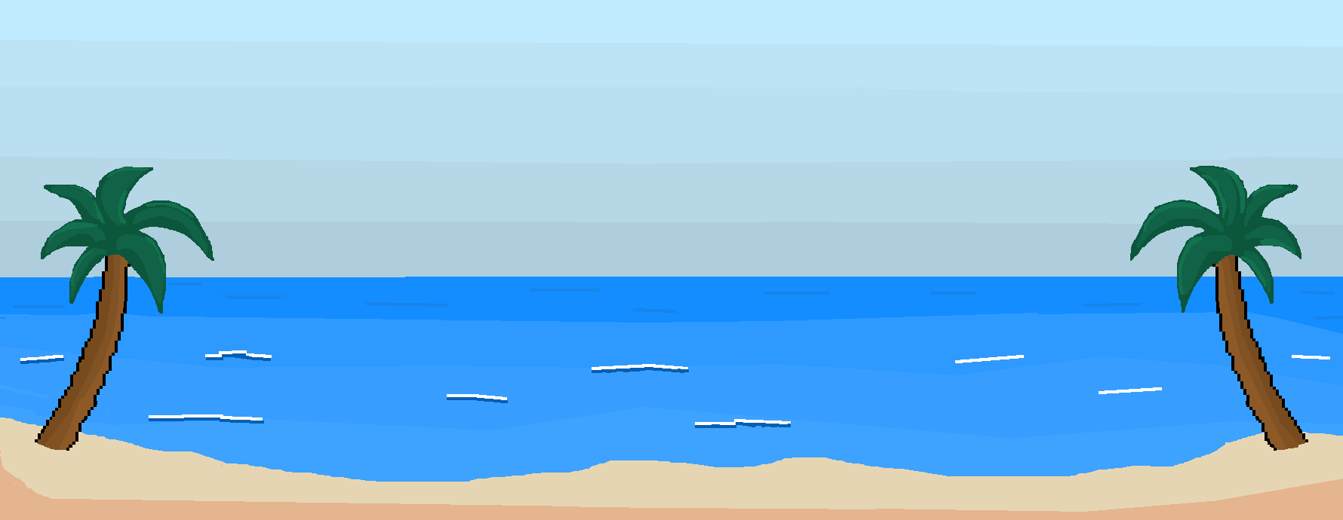

Snow Town design - Angelique:
Going to add:
Thicker snow layer underneath the buildings
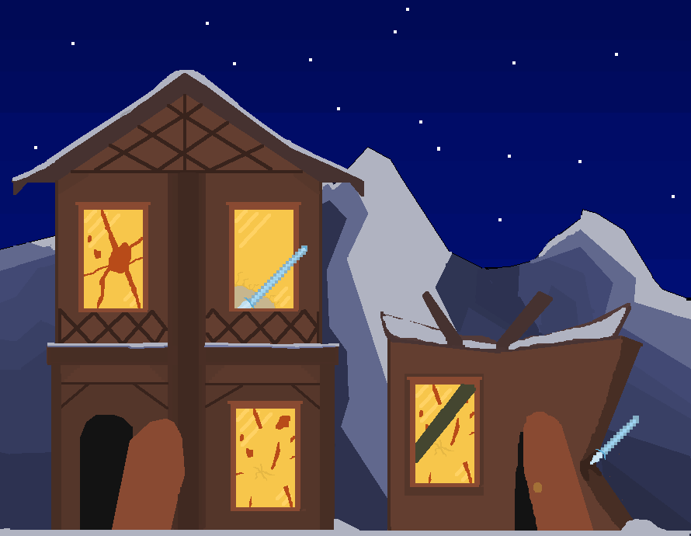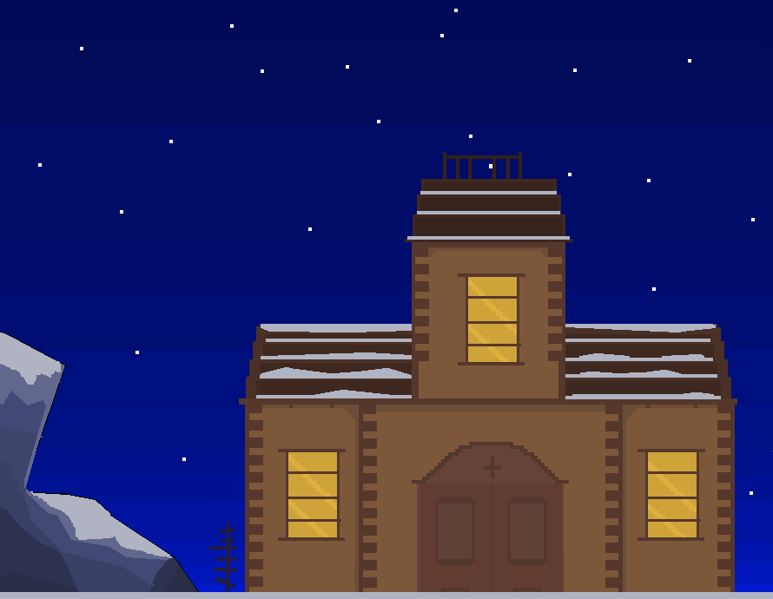

Character Designs:
Main character- Human
PHASE 1: Character Concepts
(Categorized by Race and Gender)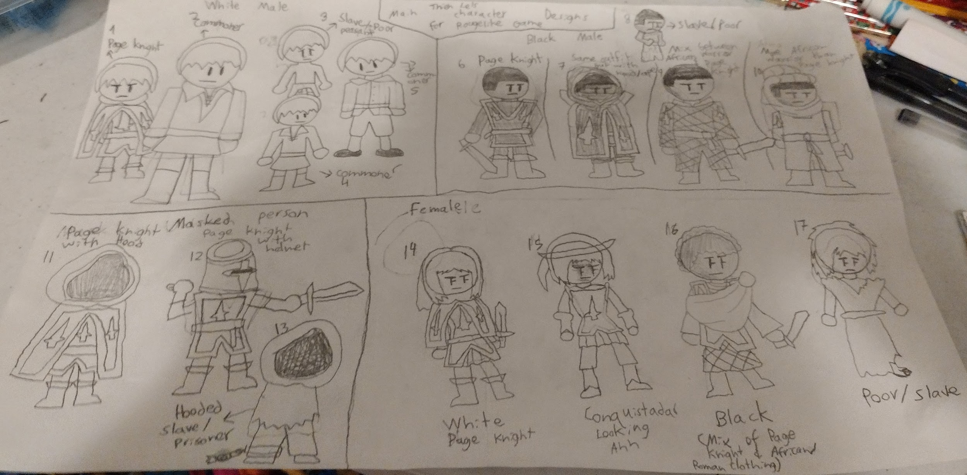
Winner for Phase 1:
1st Place(3 Votes - Juda, Josue, Martin) - Page Knight with Hood
Runner Ups:
2nd Place(2 Votes - Chris, Angelique) - Page Knight with Helmet (I might use this design in the future)
3rd Place (1 Vote - Josue) - Black Page Knight with Hood.

Phase 2: Character Colors
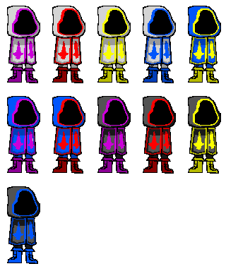

Phase Two Results:

All Tied

Blue-Yellow (Josue):
Black-Yellow(Juda):
Black-Blue(Chris):
White-Red(Angeliue):
White-Yellow(Angeliue):
Go with the Poll(Martin, Thien):

Phase Three: Poll with whole workplace

Phase 3 Winner:
Character Design: Page Knight with Hood
Color-Design: Black-Blue and Black-Purple

My Group decided on Black-Blue - Thien Le

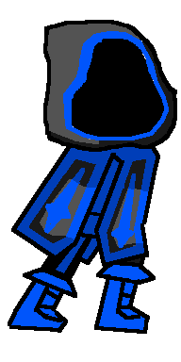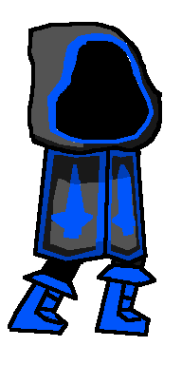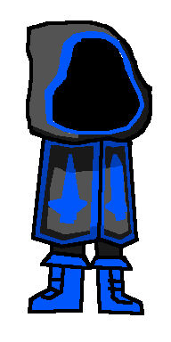
Main’s Weapons (Thien Le):

2 Real Angels

Main Boss- Demon:

Placeholder/ Original concept - Faker Form(Chris H)

Faker Form - Thien Le

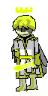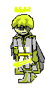

Original Concept Phase 1 (Thien Le)
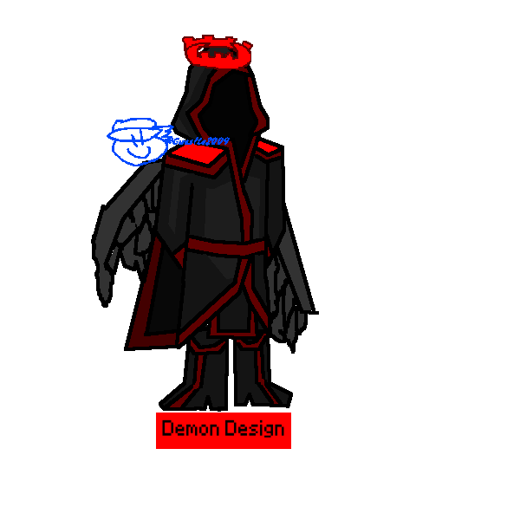
Original Concept Phase 2 (Chris H)
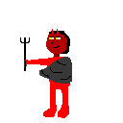

Snow town mobs (Angeliue):
Minor enemies- Snow Meisters with ice spears(I could change them to be a magic type)

Snow Gremlin(close range fighters)
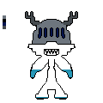

Mid Tier Enemies- Ice Skeletons (Long range type)

Snow Town Mobs (Chris H)
Elf -
  - 
Sagbae -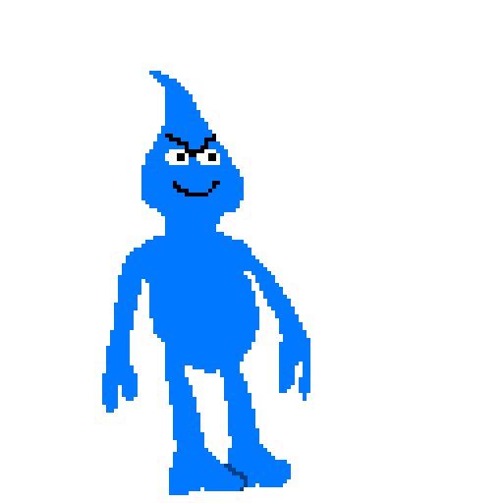

(Scrapped) Water town mobs:

Mermaid Pack (Thien Le):
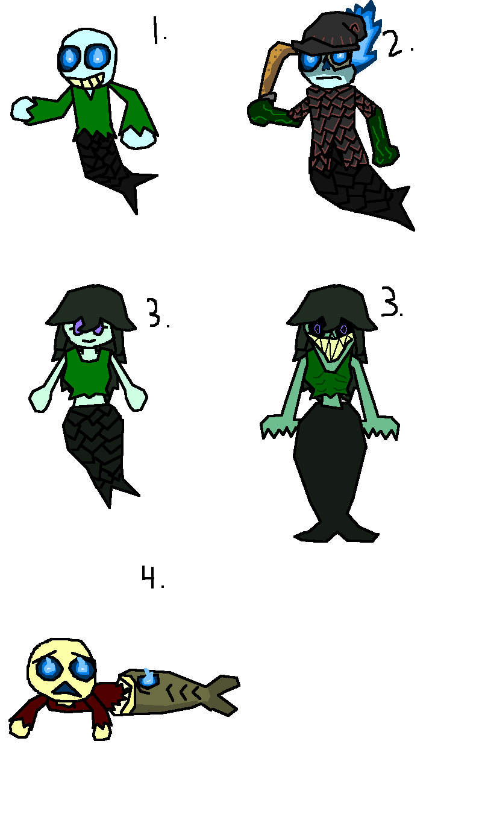
Pirate Skeleton (Chris H):
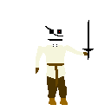

(Scrapped) Desert town mobs

Plain town mobs(Thien Le):

(Scrapped) - Undead Mobs
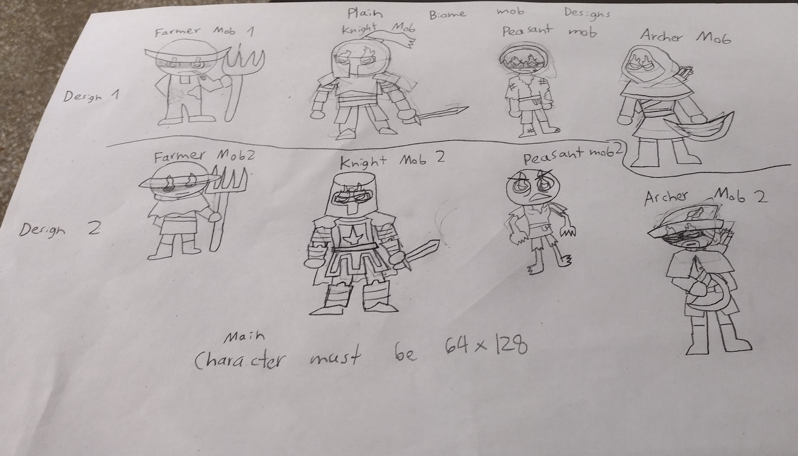
Thien - Goblin (Melee):
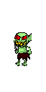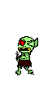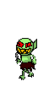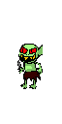
Thien Le - Witch (Magic):
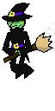

(Biome Scrapped but we keep the skeleton) Rain forest mobs(Thien Le):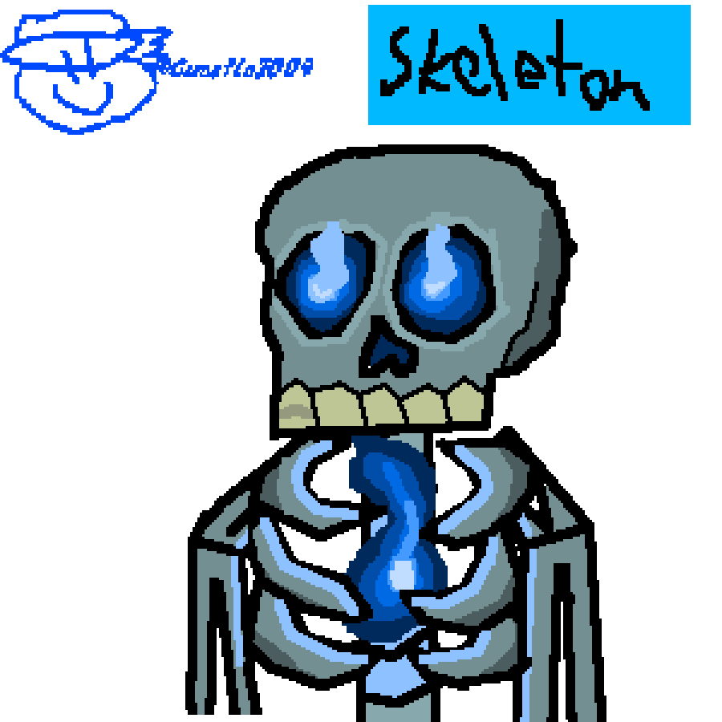

Volcano mobs:

(Scrapped/ Redesigned to fit into lore) - Thien Le - Essence Monster:
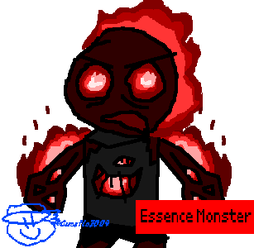
Lava Blob - Chris H:
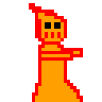

(Scrapped?) Mini Boss Character Designs (Thien Le):
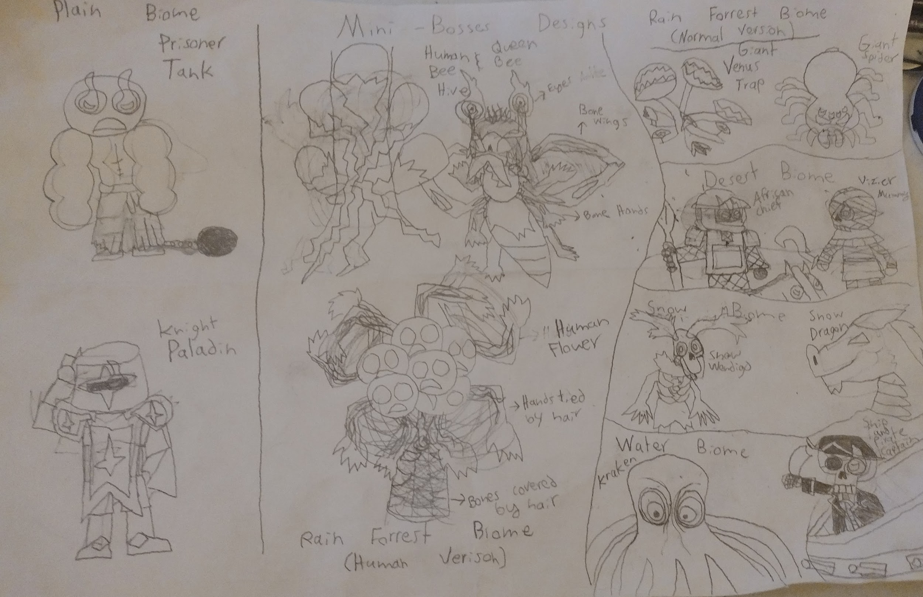

UI Designs:

Health Bar - Thien Le:

Dash Meter - Thien Le:

Other Designs:

Cloud Poof Thingy - Thien Le:


Classes

Stats:
HP
Strength
Knockback
Dash Distance
Speed
Specific Resistances
Dash Cooldowns
Parry window
Parry Damage

Bruiser/Tank
In your face rushdown gameplay, very tanky, extra damage and health, speed is very slow, high knockback. Slightly bigger hitbox too
- Sword/ axe / mace / scythe (the bigger the weapon the bigger the range, and the slower the swing)
- Shield would be used for parry
- Spear for ranged attack

HP: 200
Strength:
Knockback: TBC
Dash Distance: 128 (2 tiles)
Speed: Slow
Specific Resistances: idk someone give ideas
Dash Cooldowns 4 sec
Parry window: 1 sec
Parry damage: 175%

Archer
For cowards, nah jk, long ranged with a variety of useful projectiles, lots of damage, but can get overwhelmed with hordes, strength is average, decent mobility
- Bow and arrow
- Maybe muskets or canons
- Parry?
- Melee attack would be a spear

HP: 125
Strength:
Knockback: TBC
Dash Distance: 192 (3 tiles)
Speed: Average
Specific Resistances: idk someone give ideas
Dash Cooldowns 4 sec
Parry window: .75 sec
Parry damage: 125%

Assassin
strength is below average, mobility is god tier, fastest class
- Daggers(throwable), fast swinging knives, boomerang that pierces through enemies and ricochets of walls
- Parry would be a knife
- Sprint and Dash

HP: 100
Strength:
Knockback: TBC
Dash Distance: 320(5 tiles)
Speed: Fast
Specific Resistances: idk someone give ideas
Dash Cooldowns 2 sec
Parry window: .2 sec
Parry damage: 200%

Mage/Wizard
strength is the weakest, great taking out hordes of enemies, mobility will be slow,
- Spells(melee and long range)
- 2 ways to defend
- A aimable shield can be used to block projectables
- And a spell parry to parry

HP: 150
Strength:
Knockback: TBC
Dash Distance: 192(3 tiles)
Speed: Fast
Specific Resistances: idk someone give ideas
Dash Cooldowns 3 sec
Parry window: .5 sec
Parry damage: 150%

Doctor/Healer??? (not confirmed)
- I like the idea of using potions and or area of effect attacks
- But a healer might be OP, if we do want to implement a healer class we would have to balance it by giving them weak stats. In cuphead when you use the chaser shot, ur damage gets weakened. Better accuracy with lower damage.
- Staff for melee

Character Animations
- Idle
- Walk
- Dash
- Sword
- Axe
- Death
- Sprint animation

Add more stuff down here

Enemies:

Types of enemies
- Melee
- Long Range
- Magic(AOE, buffs, debuffs)
- Tanky Units
- Special Enemies (Unique attacks)
- Bosses

Possible Snow Mobs:
Minor enemies- Snow Meisters with ice spears(I could change them to be a magic type)
Also minor enemies- Snow Gremlin(boxing fight style)

Mid Tier Enemies- Ice Skeletons (Long range)

Snow Boss(TBD)

Possible water town mobs:
Boss idea- Water serpent(The player would have to shoot

Environments(not in order);
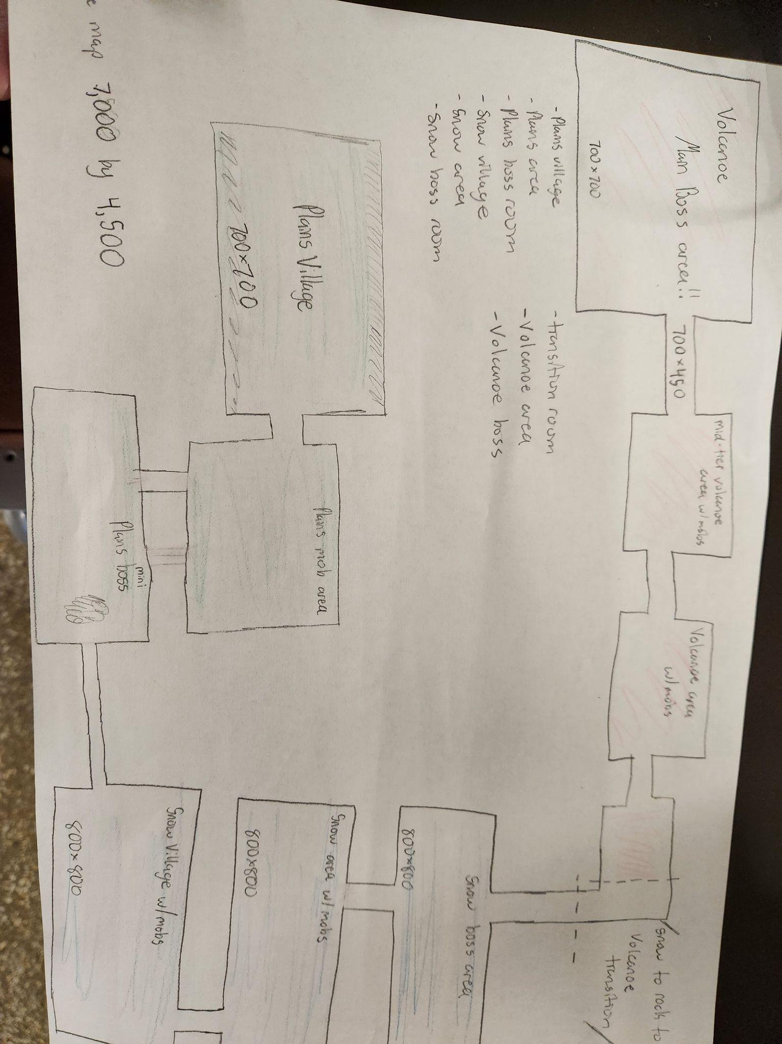
Enemies: We will have only one enemy of each type for each environment

If an enemy loses it can be repurposed and used in another environment

Coding the enemy’s AI is not difficult, I (juda) can reuse code from similar enemy types to make them, it's only a matter of who is gonna make the art. So just keep that in mind, we don't want to overwork the artists. If we have to cut content due to time it'll be fine.

Plains(Starting level)
Map parts:


Environment Description:
- Tutorial, very basic mobs with little to no magic effects and debuffs.
Map parts

Enemies:
- Melee
  - Goblin
- Long Range
  - Skeleton
- Magic(AOE, buffs, debuffs)
  - Witches
- Tanky Units
  - Stone Golem
- Special Enemies (Unique attacks)
  - Spider
- Bosses
  - Vampire

Snow

Environment Description:
- pluh

Enemies:
- Melee
  - Snow Meisters
- Long Range
  - Snowmen(throws snowballs)
- Magic(AOE, buffs, debuffs)
- Tanky Units
  - Snow Gremlin
- Special Enemies (Unique attacks)

- Bosses
  - Sagbae

Lava
Environment Description:
- Burning enemies, There is lava on the ground,
Enemies:
- Melee
- Magma Wolves
- Long Range
- Burning Skeleton
- Melee and Long Range
- Lava Blob
- Magic(AOE, buffs, debuffs)
  - Small Dragons
- Tanky Units

- Special Enemies (Unique attacks)

- Bosses
  - Demon

